Name : Vishal Jha

Batch : Data Engineering

Date : 02-02-2024

Topic : Python Coding Challenge (Q2. Lambda and JSON)

Q2. Execute with one example Lambda Functions in Python & Read JSON Strings to Python dicts or lists.

Here's an example that demonstrates the use of lambda functions in Python and also shows how to read JSON strings into Python dictionaries or lists using the json module.

1. Lambda Function : Lambda functions are anonymous functions defined using the lambda keyword. They are commonly used for short, one-time operations. Let's create a simple lambda function that squares a given number.

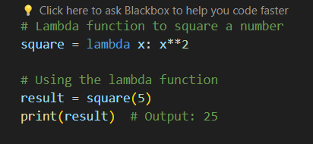

Output :



1. Reading JSON Strings to Python dicts or lists : Assuming you have a JSON string like the following.

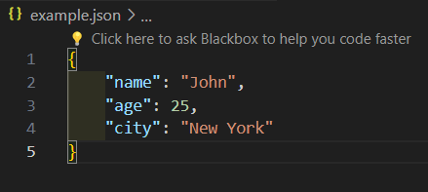

1. You can use the json module to convert this JSON string into a Python dictionary:

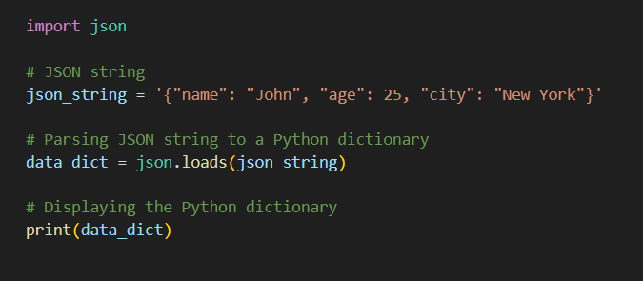

Output :



1. If you have a JSON array (list in Python), the process is similar:

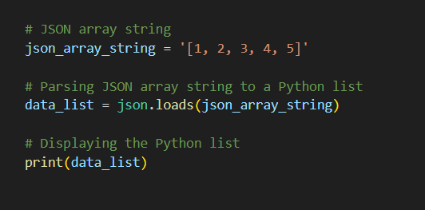

Output :



1. Complete Code :

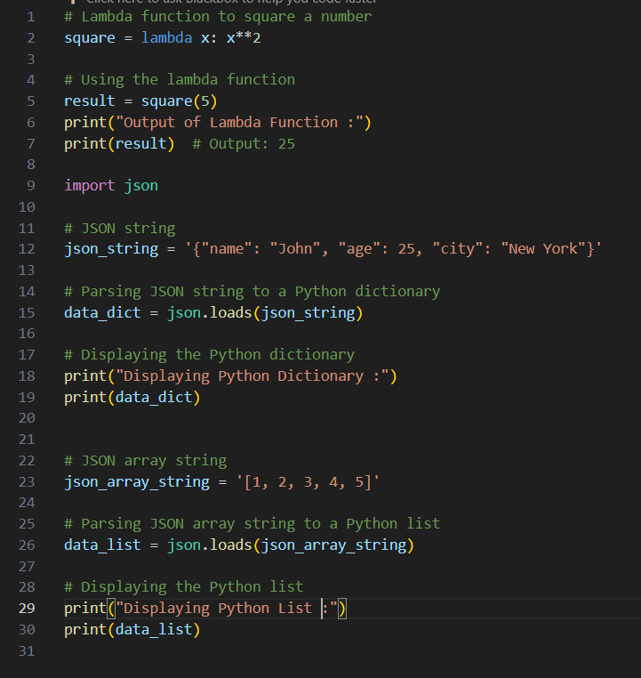

1. Output :

